Document Comparison software’s

1. PandaDoc is a considerable option if you need a better PDF apparatus because it comes with technological features and continual upgrades. As a result, multiple users refer to it as an all- round automation tool.

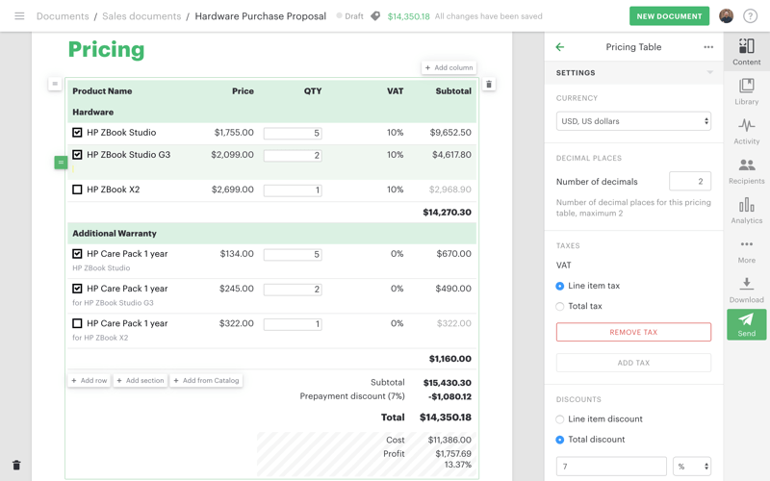

**Features**

Authenticates using unlimited electronic signature

Tracks task progress

Uses advanced document analytics

It provides reminders and expirations

mobile PDF SDK, it is mobile

**Pros**

It provides analytics reports that helps businesses increase their wins

It includes a calculator for tax calculations

**Cons**

Navigation t other fields is difficult

It does not possess the key features for PDF manipulation.

[Free Download PandaDoc >>](https://www.pandadoc.com/)

1. **GroupDocs**

GroupDocs creates easy to use, comprehensive online document management APIs for .NET, Java and Cloud, as well as a range of Cloud apps that improves document collaboration for organizations of any size.

Our goal is to make the lives of developers who work with document management systems easier by giving them tools that save them time and effort. Document management – whether it's gathering signatures, posting documents on websites or collaborating with others to improve a text – should be easy. This is our vision - Enable applications that allow people to work faster, together.

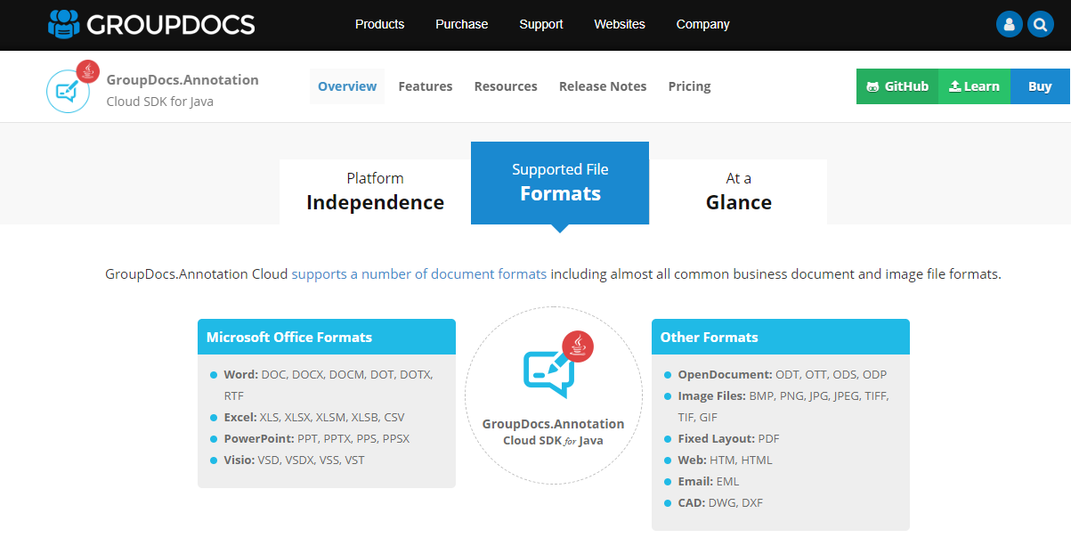

[Pricing:](https://purchase.groupdocs.cloud/pricing)

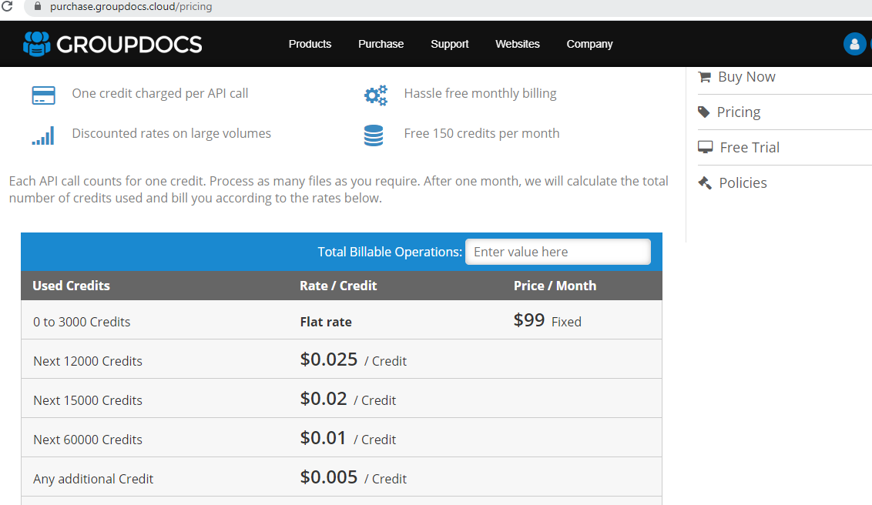

[Free Download](https://www.groupdocs.cloud/)

1. **PDFTron**

PDFTron is software with multiple basic and advanced features that facilitate the manipulation of PDFs. PDF SDK is well supported such that it does not need third-party software to function properly. It offers numerous PDFTron license options according to your business model and requirements. They include Enterprise and OEM redistributable licensing.

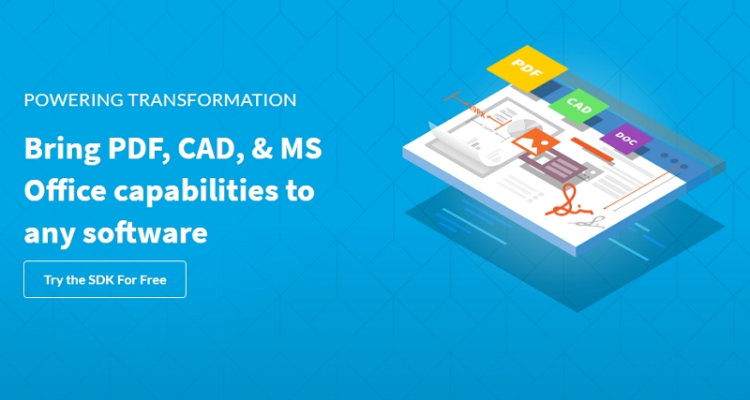

PDFTron pricing for licensing starts at $4000 annually. According to PDFTron Glassdoor, the PDFTron creators are pleased with their task and work environment.

The features include:

* Annotation and collaboration
* Format conversion
* Document security through redaction and password protection
* Data extraction
* PDF manipulation through editing
* Creation of optimized and compliant PDFs

Pricing : <https://www.pdftron.com/licensing/>

[Free Download](https://ssl-download.wondershare.com/pdfelement-pro_full5239.exe)

Comparison Table :

|  |  |  |
| --- | --- | --- |
| Queries\Companies | Aspose Or GroupDocs | PDFTron |
| File Comparisons | This tailored to our requirement and any format file can compared  Documentation Link:  <https://docs.aspose.com/display/wordsjava/Home> | Any format file will convert to pdf then compare, limitation pdf as input  Documentation Link: <https://www.pdftron.com/documentation/java/get-started/integration/windows/> |
|  | Live Demo [Word Comparison](https://products.aspose.app/words/comparison) | Live Demo : [PDF Comparison](https://www.pdftron.com/webviewer/demo/compare-files) |
| Annotations | For format file like Word, Excel, Powerpoint, Email and more | For format file like Word, Excel, Powerpoint, images and PDF |
|  | Live Demo : [Word](https://products.aspose.app/words/annotation), [Excel](https://products.aspose.app/cells/annotation) | Live Demo : <https://www.pdftron.com/webviewer/demo/> |
| CAD Files View | Live Demo:  [Aspose.CAD Viewer](https://products.aspose.app/cad/viewer)  [Aspose.CAD Conversion](https://products.aspose.app/cad/conversion) | Live Demo: <https://www.pdftron.com/webviewer/demo/cad-viewer> |
|  | GroupDocs or Aspose Total Java: <https://docs.aspose.com/display/totaljava/Home> | PDFTron  <https://www.pdftron.com/documentation/java/download/windows/> |
| Pricing | Pricing:  <https://purchase.groupdocs.cloud/pricing> | Pricing : <https://www.pdftron.com/licensing/> |